SolidWorks mechanical design task 1 submission

Rectangular Base Plate With Holes

Step 1: Open SolidWorks and Set Units
1. Open SolidWorks
2. Click New - Part
3. Go to Options - Document Properties - Units
4. Set units to MMGS (millimeter, gram, second)

Step 2: Create the Base Sketch
1. Select the Top Plane
2. Click Sketch
3. Draw a rectangle using Center Rectangle
4. Apply dimensions:
. Length: 160 mm
. Width: 100 mm

Step 3: Fully Define the Sketch
. Ensure all sketch lines turn black
. Apply constraints:
. Horizontal
Vertical
. Coincident
. Avoid under-defined sketches

Step 4: Create 3D Solid Using Extrude
1. Exit Sketch
2. Click Features - Extruded Boss/Base
3. Set thickness to 10 mm
4. Click OK

Step 5: Create Holes (Two Methods Allowed)

I use Method 1: Sketch + Extrude Cut
1. Select top face
2. Create a new sketch
3. Draw circles at corner locations
4. Dimension hole diameter: 12 mm
5. Apply symmetric offsets from edges
6. Use Extruded Cut - Through All

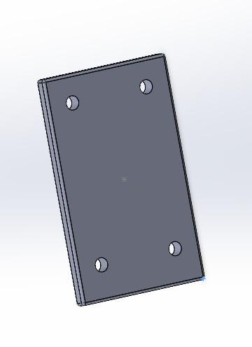

Step 6: Apply Fillets or Chamfers (Optional but Recommended)
. Apply small fillet:
. Radius: 2 mm
. Improves realism and manufacturability
Use Features - Fillet

Test your model : I played with different planes & dimensions
. Edit length or width dimension
. Check if holes adjust automatically
. Ensure no sketch errors occur
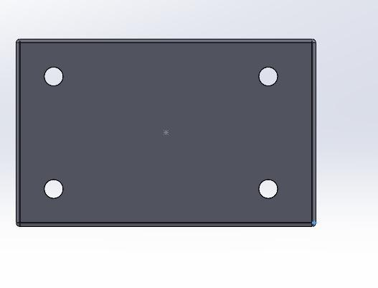

ALSO I’M SUBMITTING THE DESIGNING FILES IN “ GITHUB “ PROFILE .

Task 1 Completed

